Cover Photo  Courtesy of:  Arkansas Department of Parks & Tourism  Photographer:  Bernie Jungkind  Photo is of:  Whitaker Point in the Ozark National Forest | 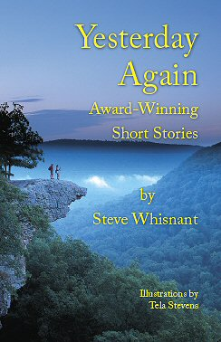  Yesterday  Again  By  Steve  Whisnant  His Collection of  Award-Winning  Short Stories  SkyMacSyd  Publishing  www.stevewhisnant.com | Yesterday  Again  By  Steve  Whisnant  His Collection of  Award-Winning  Short Stories  SkyMacSyd  Publishing  www.stevewhisnant.com | Yesterday  Again  By  Steve  Whisnant  His Collection of  Award-Winning  Short Stories  SkyMacSyd  Publishing  www.stevewhisnant.com | Yesterday  Again  By  Steve  Whisnant  His Collection of  Award-Winning  Short Stories  SkyMacSyd  Publishing  www.stevewhisnant.com

